**Khyber Pakhtunkhwa:**

Kaghan Valley

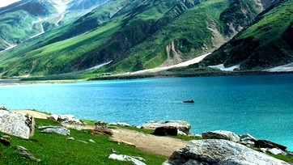

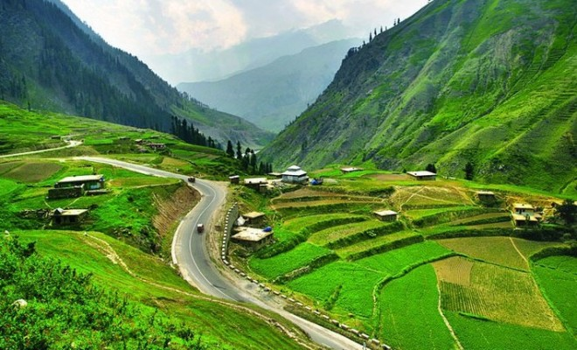

**Kaghan Valley** is an alpine-climate valley in Mansehra District of the Khyber Pakhtunkhwa Province of Pakistan. The tourists from across the country come to visit this place. The valley extends 155 kilometres (96mi), rising from an elevation of 2,134 feet (650 m) to its highest point, the Babusar Pass, at 13,690 feet (4,170 m). Landslides caused by the devastating 2005 Kashmir earthquake closed the Kaghan Valley road and cut off the valley from the outside. The road has been rebuilt.